Northern-Style Boiled Dumplings (Jiao Zi)

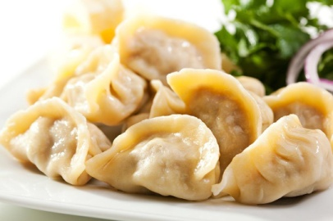

Makes about 36 dumplings.

To cook:
Pinch of dried ginger powder
1/2 pound ground pork
1 egg, beaten
2 tsp Shaoxing wine
2 Tbsp chicken stock
1 tsp sesame oil
Salt
About 2 Tbsp minced Chinese chives, yellow chives, or garlic
Pack of round dumpling wrappers (you’ll need around 36 wrappers)

To serve (optional):
Light or tamari soy sauce
Chinkiang or Shanxi vinegar (black Chinese vinegar)
Chile oil or ground chiles (e.g., Lao Gan Ma sauce)

Preparing the filling:
Put the pork in a bowl and add the egg, ginger, Shaoxing wine, stock, sesame oil and salt to taste, with 1 Tbsp water. Mix well. Finely chop the chives or garlic and add them to the pork. Mix well.

Set a large pot of water (like a stock pot) to boil. Fill the pot only 2/3 full of water, as you will be adding more water.

Wrapping the dumplings:
Fill a small dish with cold water and have it on hand, along with a large empty plate or tray to hold the completed dumplings. Place about 1 Tbsp of the pork mixture in the center of a wrapper. Dip your finger in the dish of water and run it around the edge of the wrapper. Then seal the wrapper with a few little pleats. Lay the dumpling on the tray or plate. Wrap the remaining dumplings in the same way.

Cooking the dumplings:
Drop some of the dumplings into boiling water and cook them for 4 to 5 minutes. Don’t crowd the pot – I put 15 in my 8 quart stock pot. Each time the water comes back to a rolling boil add about 1/2 cup of cold water to calm it down, so the dumplings do not fall apart. You should do this twice before the dumplings are cooked. When they are cooked, they will float to the top of the water. Remove the dumplings with a slotted spoon and place in a serving dish. Repeat with the rest of the dumplings. You can drizzle a little sesame oil on the cooked dumplings to keep them from sticking together.

Serve and eat!

