Date/Time of Submission (leave blank)

Families with Children from China—Austin, Texas Chapter
Scholarship Application for Volunteer/Welfare Trip

00/00/0000
Name of Applicant Date of Birth

Address
(512) 000-0000
Email Address Phone Number

Submission Criteria for Volunteer/Welfare Trip Scholarship
For consideration of this scholarship, applicants must be current FCC members in good standing
(per the 2014 membership roll), be between the ages of 13 and 23 at the time of submission, who are preparing to return to China as part of a volunteer trip where s/he will be directly involved in projects that assist the welfare of children currently in foster or welfare institutes. Note: this is not a scholarship for
a heritage trip.
Additionally, the award recipient agrees to provide the board via email a three-paragraph post trip summary. The board may choose to publish in the FCC-Austin newsletter (without mentioning the awardee by name if desired) that the scholarship has been awarded.
Rubric
Up to 25 points will be awarded based on the thoroughness of the answer (10 points), details included
(10 points) and depth of the explanations (5 points).
Judging
- Up to 25 points will be awarded based on the thoroughness of the answer (10 points), details included (10 points) and depth of the explanations (5 points).
- The submission with the most points will be awarded the scholarship.
- In the event of a tie, the scholarship award will be divided.
- A judging committee independent from the FCC-Austin board will blindly judge the essays according to the rubric.
Submission Methodology
Complete the form on the previous page and respond to one of the following essay topics in a typewritten response of one to two pages in Arial 12 point font, double spaced, with 1" margins. Include in your essay response two paragraphs that describe your China Volunteer/Welfare Trip plans.
Please Select and Respond to One of the Following Questions:
- Describe what you have done to prepare yourself to return to China. (Feel free to describe books you might have read, cultural events you have attended, and/or classes you have taken with an Asian theme.)
- What are you looking forward to the most from this trip and why?
- What do you hope to learn about yourself and China from this experience?
- When you return, how would you hope to share this experience with your family and your community?
Timeline
- May 6, 2014 at midnight: Application is due to the coordinator. The coordinator will submit the essays to the judging committee. Late applications will not be accepted under any circumstances. The time stamp received on the coordinator’s inbound email will serve as the acceptance date/
time. Submit essays to: Jcgoodridge@gmail.com. You will receive an email confirming receipt of the essay.
- May 7, 2014: Selection process begins.
- June 4, 2014: Application process ends and coordinators tally the rubrics.
- June 11, 2014: Recipient(s) is/are announced and the scholarship(s) is/are distributed.
Note: FCC reserves the right to award scholarships only if the judges deem essays have met the selection criteria.
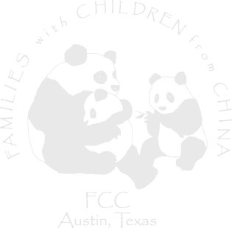

Date/Time of Submission (leave blank)

Essay for Volunteer/Welfare Trip Scholarship

Essay Text Essay Text Essay Text Essay Text Essay Text Essay Text Essay Text Essay Text Essay Text Essay Text Essay Text Essay Text Essay Text Essay Text
Essay Text Essay Text Essay Text Essay Text Essay Text Essay Text Essay Text Essay Text Essay Text Essay Text.

